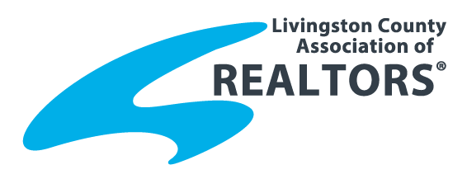
2015 Volunteer of the Year
Name of Nominee:
Nominated By:
Home Address:
City, Zip:
Telephone:
Email:

Contributions, Activities and Achievements:
- Name(s) of volunteer organization(s)/events nominee participates in:

- Hours per year/month/week/day:

- Volunteer work:

- Other:

Please return this nomination form by Friday, July 31, 2015 to:
Livingston County Association of REALTORS®
2060 Grand River Annex, Suite 800, Brighton, MI 48114
P: (810) 225-1100, F: (810) 225-9205
Email: paml@lcar-mi.com

