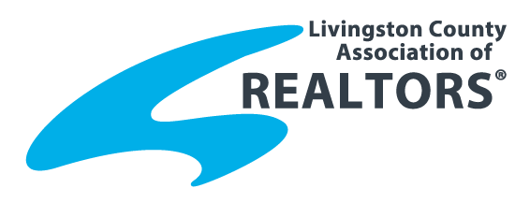
2015 REALTOR® of the Year
Nomination Form
Name of Nominee:
Nominated By:
Brokerage:

REALTOR® of the Year is the highest award bestowed upon a REALTOR®. The LCAR winner is submitted for the Michigan REALTORS® Annual ROTY. Achievements and Contributions:
- To the REALTOR® Organization (30%) (May include activities such as: association activities at the local/state/national level; committee work, business meetings, education events, membership and offices held in any chapter of Institutes, Societies, and Councils, advocacy and issues; attendance at state/national conventions; spirit and faithfulness to principals of organized real estate, as well as the laws and regulations of this board and NAR’s Code of Ethics.

- To the Real Estate Profession (30%) (May include activities such as: overall business achievements-both real estate related and otherwise, designations held, public recognition of business conduct, service to clients, imaginative and creative advertising program, rehabilitation work, land utilization, etc. efforts to encourage good real estate practice among other real estate brokers):

- To the Community (40%) (May include activities connected with work in local chambers, youth or religious groups, etc.: cultural contributions to the community; civic clubs, membership and offices held; public welfare campaigns; political offices held (national, state, local) with or without pay: time spent with the press and general public explaining the real estate profession)

Please return by Friday, July 31, 2015 to
Livingston County Association of REALTORS®
2060 Grand River Annex, Suite 800 Brighton, MI 48114
O: (810) 225-1100, F: (810) 225-9205 email: paml@lcar-mi.com

