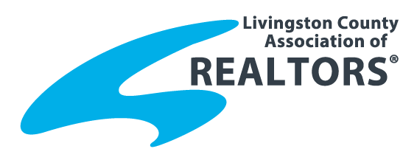
2015 Affiliate of the Year
Name of Nominee:
Nominated By:
Home Address:
City, Zip:
Telephone:
Email:

Please explain the nominees Contributions, Activities and Achievements:
- Association activity: Committees, meeting attendance

- Business Activity: Memberships in business organizations, company recognition

- Community activity: Local service groups, charitable organizations

- Other:

Please return this nomination form by noon on Friday, July 31 to:
Livingston County Association of REALTORS®
2060 Grand River Annex, Suite 800, Brighton, MI 48114
P: (810) 225-1100 F: (810) 225-9205
Email: paml@lcar-mi.com

